PE – KE Worksheet

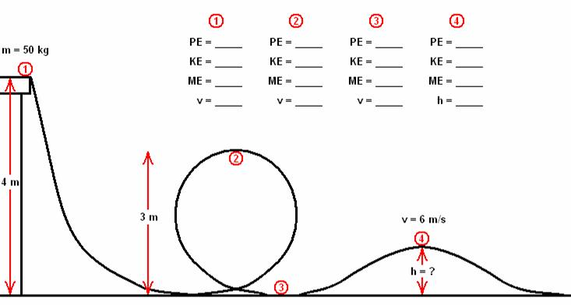Instructions: add your height in m to the initial distance at position 1 (5.2 m + ht), add your weight in kg to the initial mass (106 kg + weight). These are the only values you change. Perform the calculations to fill in the table below for 1-4. Show all work on the back of this page. Note: ME = total energy, v = velocity.

106 kg

5.2 m

